**IFT 166 Introduction to Internet Networking  
  
Lab 25**

**Wireless Networking - Set up A wireless network with 2 access points**

Co-authored by Alejandro Soto-Gil

**Objective:** Set up a wireless network with 2 access points and allow communication between user devices on different access points.

**After you complete each step, put an ‘x’ in the completed box or answer the open question**

1. Create the following network topology on Packet Tracer

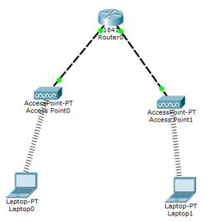

Assign an IP address of 192.168.1.1 to Fa0/0, and 192.168.2.1 to Fa0/1 on the router. Connect to the two access points using copper cross-over connection.



1. Now we will set SSID’s for port 1 of both access points. I used upstairs and downstairs, but you can name the SSIDs whatever you want. Make sure you set the port status to on before proceeding.

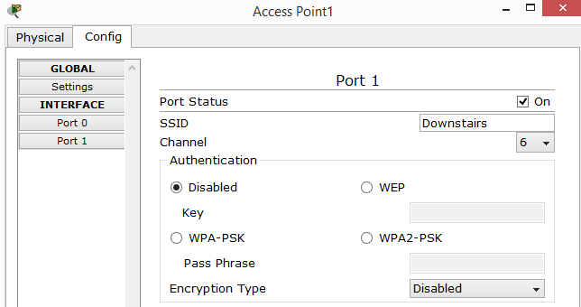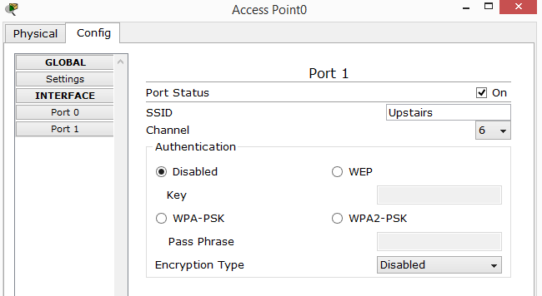



1. We will now add wireless adapters to our laptops. First thing we need to do is power off the laptop. Click on the laptop and on the Physical tab, scroll down and you will see the power button in yellow, turn it off.

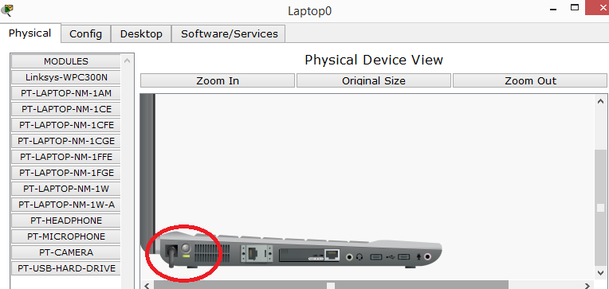



1. Drag the module PT-LAPTOP-NM-1W onto the port and then make sure you turn on the laptop.

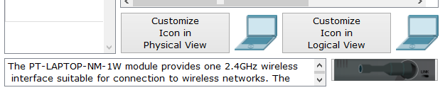



Repeat the same process for the second laptop



1. In order to connect to our access points, we must configure the wireless adapter in our laptops to find our access points.

This is achieved using our SSID to connect each laptop to it’s own access point. i.e. Upstairs, and Downstairs. On both laptops (wireless interface), assign the correct SSID to the Wireless connection.

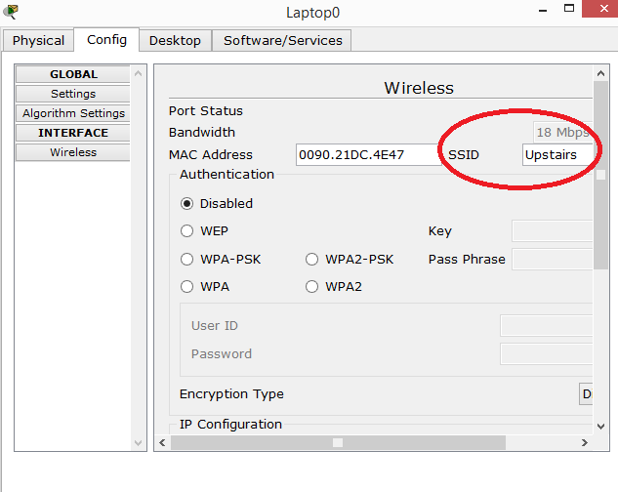



Now assign the IP addresses to the laptops i.e. 192.168.1.2 and 192.168.2.2.   
  
Make sure to match these up with the IP address of the router port.



1. We now have two laptops connected to the two access points as shown in our original network topology.   
     
   What happens when you try to ping laptop0 from laptop1? Why is this?

1. In order to have communication between the two laptops, we must set the default gateway for each laptop

Be sure to input the correct gateway for each laptop based on which port on the router it is connected to.



1. You should now be able to ping each laptop to the other as you have now set up a successful wireless network with access points!

